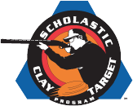

www.WausauSkeetandTrapClub.com 153200 County Road WW, Wausau, Wisconsin 715-675-7227
Scholastic Clay Target Program 2024
Students from 6th through 12th Grade

Orientation/Registration: February 27, 2024, anytime from 5:30 pm to 7:00 pm at WS&TC

When: Sundays March 17 to May 26, 1:00 to 3:00 pm, Practice dates: March 17 and 24

Conference Dates: (Note: All conference shoots will be held at WS&TC. If not able to shoot on the date shown, arrangements can be made with the Head Coach to shoot the score in advance.)
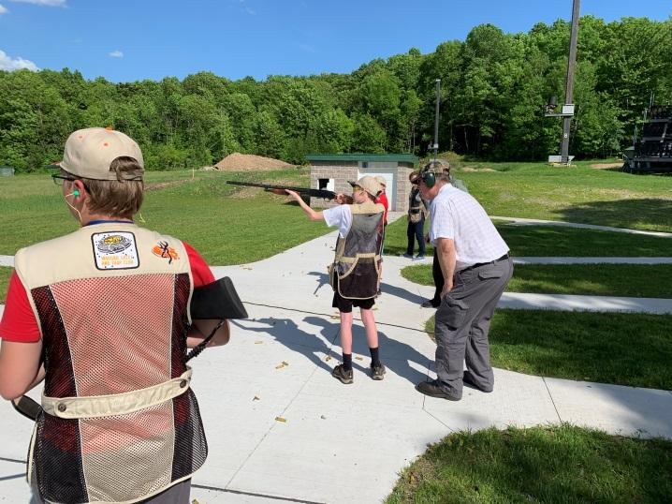
Week Competitor Sunday 1:00 pm to 3:00 pm
1 Mosinee March 31 (Easter)
2 Tomahawk April 7
3 SPASH April 14
4 Medford April 21
5 Rhinelander April 28
6 Lakeland May 5
7 Antigo May 12 (Mother’s Day)
8 Eagle River May 19
9 Merrill May 26 (Memorial Day)

Program Cost of $200* per student includes:
- Shells and targets for 18 rounds of trap
- Guns and safety equipment as required
- Registration with the Scholastic Clays Target Program (SCTP) and certified coaching
- Shells and range fees for two offsite competitions:
  - Conference Shoot – May 31 at Wausau Skeet & Trap Club
  - State SCTP Trap Shoot – June 23 at Rome, WI
- Complimentary Annual Family Membership to the Wausau Skeet and Trap Club
*Student must also agree to sell ten $10 WI SCTP Foundation raffle tickets
or pay an additional $50 fee
Andy Woodward, Head Coach: 715-574-2042, woody7c@gmail.com
Tim Kuski, Assistant Coach: 715-571-4551, tkuski@charter.net
Visit the Youth Page on our website at https://wausauskeetandtrapclub.com/youth-page/

